**Truk (Chuuk) Lagoon Scuba Trip JAN 2026 (22 JAN - 3 FEB or 26 JAN - 3 FEB)**

**10** **Days diving (12 nights) in Chuuk** – Thursday– Tuesday **$2,400**

**6** **Days diving (8 nights) in Chuuk** – Monday- Tuesday **$1,700**

****his is it, Tthe trip of a lifetime. Now is the time to visit this exotic location and see the amazing coral, fish, and of course, the wrecks. In FEB 1944 the war turned for the US in the Pacific and the Japanese were solidly on defense. Their main naval base was Truk Lagoon, the Gibraltar of the Pacific, and the target for the Americans. Most of the wrecks are within recreational limits, covered with coral and fish, and filled with artifacts.

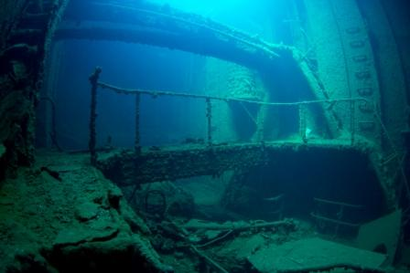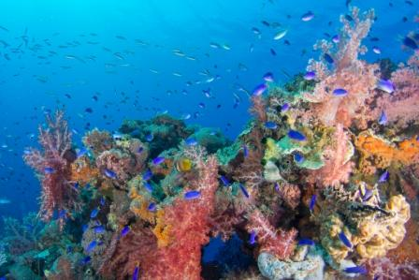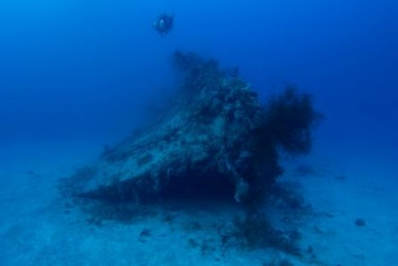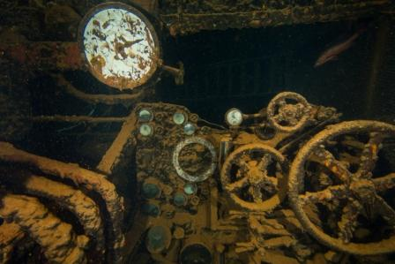

You can choose either 6 or 10 days (3 dives a day) of diving. There are several flights to get to Chuuk. The one I recommend is the Island Hopper by United but you choose how you arrive. We will dive from Friday or Tuesday thru Sunday. Monday is a rest day to off gas, tour, relax and then fly out on Tuesday.

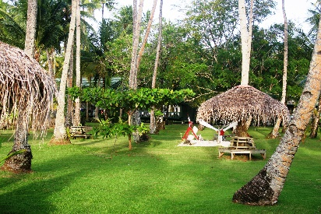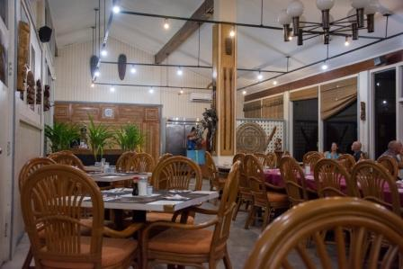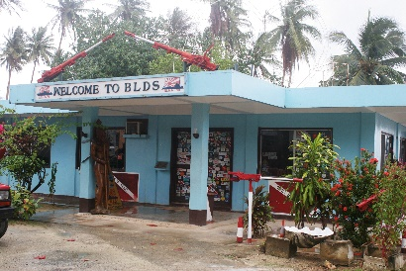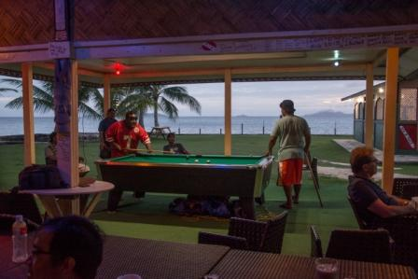

We will be staying at the Blue Lagoon Resort. There is a restaurant, souvenir shop, museum, kayaks, a small bar, large green area, and a beach along with other various amenities. Diving will be done with Blue Lagoon Dive Shop. They are very experienced and will guide the dives. I have had 8 trips to Chuuk and 6 with them. They are friendly, helpful, knowledgeable, professional, accommodating, and always amazing. We will use day boats to go to the various wrecks of our choosing around the lagoon. We will do 2 dives, return for lunch, then do a third dive. During the surface interval we may tour, snorkel, or just rest on one of the islands.

**Approx prices are 8 nights - 6 days of diving $1,700** or **12 nights - 10 days of diving $2,400. Once I have the final number I will get a firm price. This is to provide the best price possible.** If you want to dive 2 dives a day or are a non-diver, the price will be less and they can accommodate that. **Included in the price** are 3 dives a day, tanks and air, airport transfers, and a double occupancy room Thursday or Monday thru Monday.

**Not Included in price** is departure fee ($20), dive permit ($50), plane ticket, food, nitrox, tips.

| **◄ November** | **January 2026** | | | | | **January ►** |
| --- | --- | --- | --- | --- | --- | --- |
| **Sun** | **Mon** | **Tue** | **Wed** | **Thur** | **Fri** | **Sat** |
| Chuuk 10 day  Chuuk 6 day  Everyone |  | **Group 1 leaves MN** |  | 22 JAN  **Group 1 arrives Chuuk** | 23 JAN  1st day of diving | 24 JAN  Group 2 leaves MN |
| 25 JAN | 26 JAN  Group 2 arrives Chuuk | 27 JAN  Group 2 First dive | **28 JAN** | **29 JAN** | **30 JAN** | **31 JAN** |
| 1 FEB  **Last day of diving** | 2 FEB  Day off | 3 FEB  Fly out | **Arrive MN** |  |  |  |

This is an amazing opportunity to dive what has been called the World’s Best Wreck Diving. We have worked hard to put together the best trip yet to the South Pacific. The price will never be better and you will not be disappointed. The number of things to see and experience cannot be compared to in any other location. The water temperature is about 84 deg F and visibility is at least 75’. On many dives you will be able to do your safety stop looking at corals, fish, or a shipwreck. This trip is perfect for novice divers thru experienced tech divers - young and old. On my You Tube page (Hanz Lehrke) are many videos showing the amazing diving in Chuuk.

**Deposit $500.** I have room for 12 divers (6 rooms) right now. I may be able to add more space and rooms but JAN 2026 dates are filling up for the resort so to ensure you make this trip you need to send the deposit as soon as you know you are going. I must be able to let Blue Lagoon know if additional boats and rooms are needed.

If you have any questions, please let me know. Text/phone 651-208-9277 hanzlehrke@aol.com

**Sponsors:**





